

**NAME : G.Madhuri Chowdary**

**CLASS : CSE B**

COURSE CODE : 23 CSE111

**OBJECT ORIENTED PROGRAMMING SYSTEM**

**LAB REPORT**

**Department of Computer Science Engineering**

**VERIFIED BY:**

**WEEK- 1**

# **Explain the process of initializing JDK?**

**Aim:**

**Installing of JDK (Java Development Kit)**

**Download JDK:**

Open Chrome browser and search for JDK download now open the first website of Oracle to download JDK click on JDK-21 version to get long term Support (LTS)

**Installation of JDK:**

Click on the download as per your os (Linux, Macos,windows).

Once the download is completed, run the installer Click on the Next button until the installation is completed.Allow java to make changes in your device.

**Setting Environment Variables:**

Open file explorer Go to this PC ,now open windows(C) click on program files, next click on java open JDK 21, go to bin and now copy the path address. Then after in search bar, search for environment variables open environment variable go to system variables click on new, paste the copied path.

now click on 'ok' 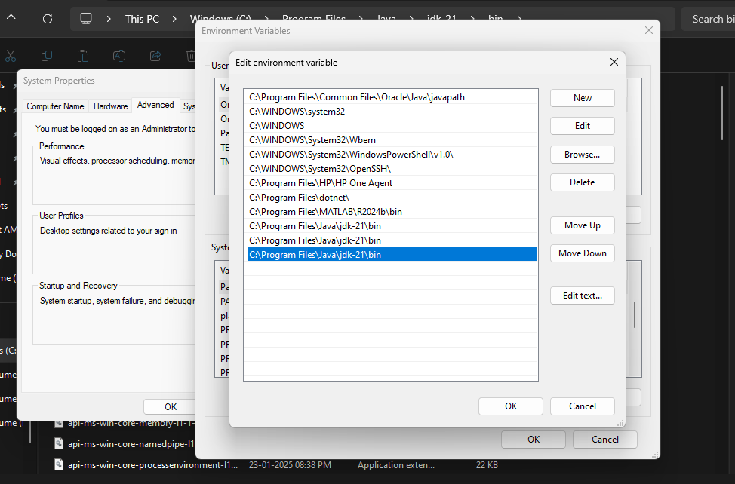

**Checking of JDK Version:**

Open Command Prompt and press on **(Windows+R).**

and now type your command and click on Enter button

**Check the Version of JDK :**

Type java--Version and click Enter

Type javac --Version and click Enter.

Simple java program for printing.

**# Name of the Class ,section and roll no of a student Open Notepad and execute command prompt**

CODE:

Class Main {

public static void main(String[] args) {

System.out.printIn ("Name: MadhuriChowdary”)

System.out .println("Section: CSE-B”);

System.out. printIn ("Rollno: AV.SC.U4CSE 24106");

}

}

**Output:**

Name: MadhuriChowdary

Section:CSE-B

RollNo:AV.SC.U4CSE24106

**WEEK-2**

**1. Write a java program to find the simple intrest required values are taken from the user ?**

**CODE:**

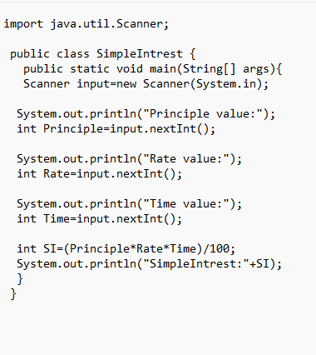

**Output:**

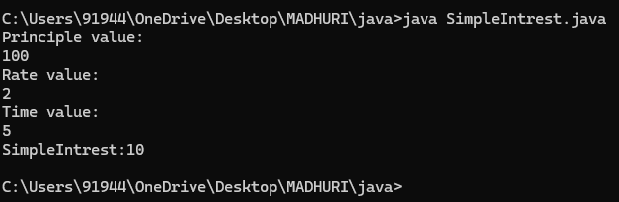

**2.Write a Java program to find the factorial of a given number ?**

**CODE :**

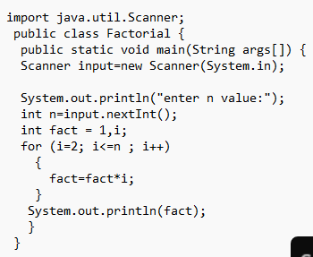

**Output :**

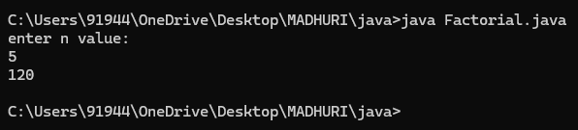

**3. Write a java program to print Fibonacci series ?**

**CODE:**

**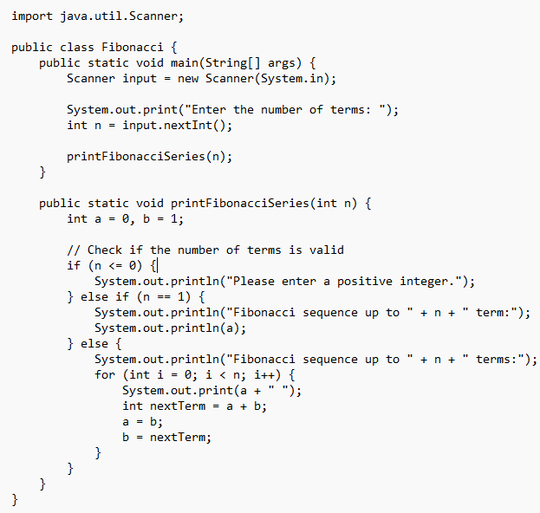  
Output:**

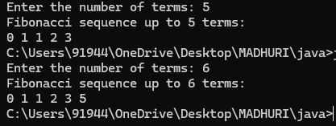

**4. Write a java program to print Area of triangle using heron’s formula ?**

**CODE:**

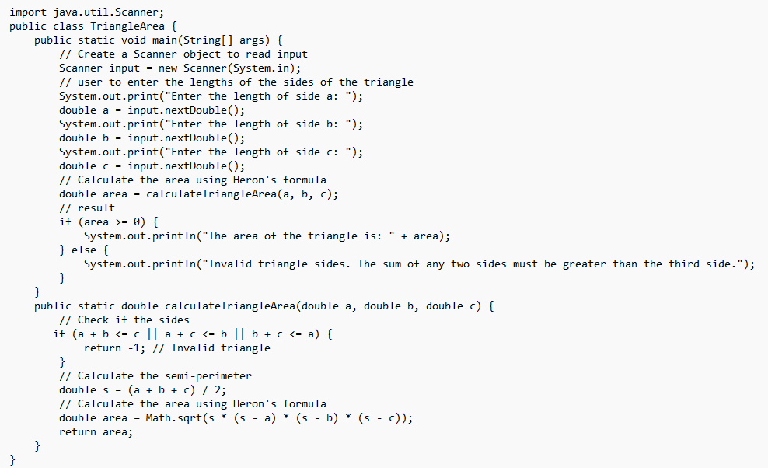

**Output:**

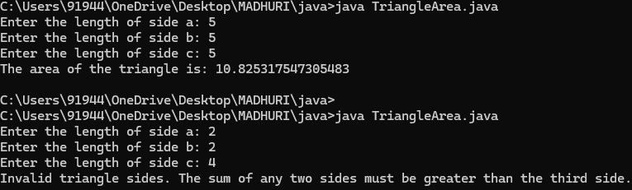

**5.Write a java program to convert temperature from Celsius to Fahrenheit and vice versa**

**CODE:**

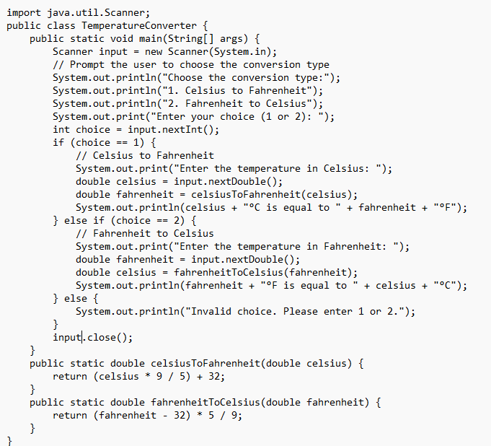

**Output:**

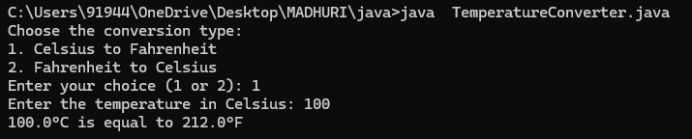

**WEEK-3**

1.**Create a java program to the following instructions?**

1. Create a class with name car
2. Create four attributes names – carcolour,carbrand,fueltype,mileage
3. Create three methods named – start ,stop,service
4. Create three objects named – c1, c2,c3.
5. Create a constructor with parameter - carcolour,carbrand,fueltype,mileage.

**CODE:**

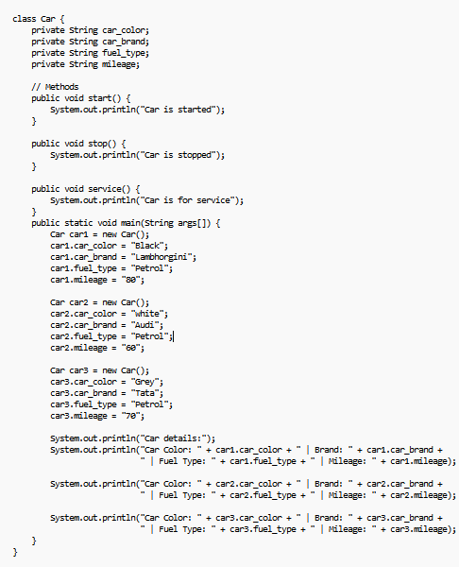

**OUTPUT:**

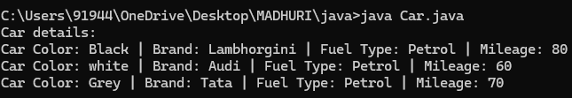

**Errors:**

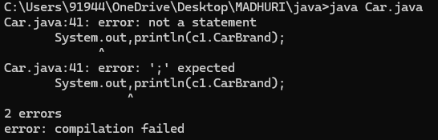

**# Rectified by replacing with fullstop (“.”)**

**Class Daigram:**

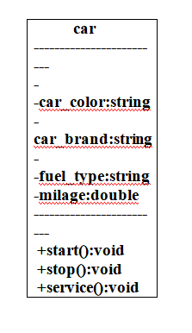

**2**. Create a class named, bank account with methods -deposit and withdraw, where the deposit method should accepts a parameter and when this method is called the deposit method should be added to current, balance in addition to that when a withdraw method is called it has to verify whether withdraw is lesser than current balance if not display there are insufficient funds

Use the constructor to display the details of the customer (Customer name, acc number, IFC, branch)

Also create two customer objects C1, C2

**CODE:**

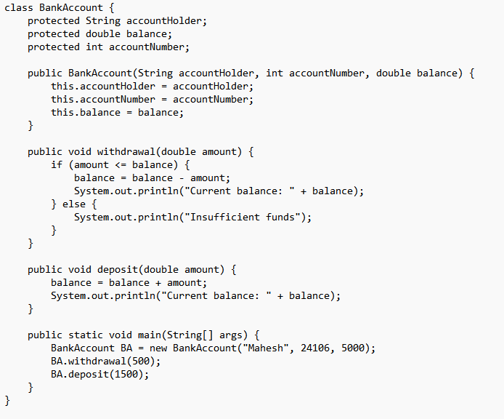

**OUTPUT:**

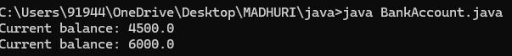

**ERRORS**

Don’t forgot semi colon .

Class should start with Capital letter .

**Class diagram:**

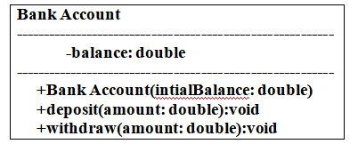

**Week-4**

1. Write a java program with class named book the class should contain various attributes such as title ,author, year of publication .It should also contain a constructor with parameters with initializes title ,author and year of publication create a method which displays the details of the book

(display the details of two book i.e, create two books and objects with details).

**CODE :**

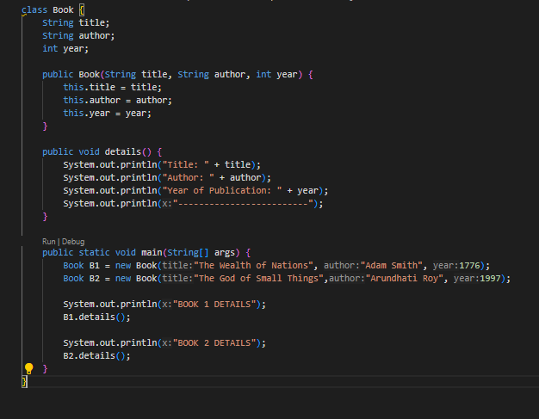

**Output :**

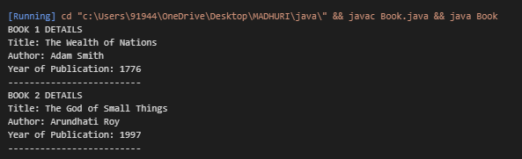

**Syntax error :**

**Forgot to keep “ } ”**

**Rectification :**

**“}” is added.**

**Class diagram:**

|  |
| --- |
| Book |
| title : String  author : String  year : int |
| + book(title: String, author: String, Year: int)  + details(): void |

1. Write a java program to create a class named my class with a static variable count of int type and initialize to zero and a constant variable pie of double data type ,initialize to 3.1415 as attributes of that class now define a constructor for my class that increments the count variables each time an object of my class is created variable each time an object of myclass is created. Finally print the final values of count and pie variables**.**

**CODE :**

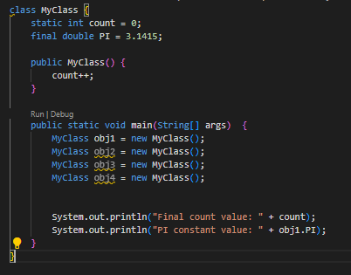

**Output :**

**C:\Users\91944\OneDrive\Pictures\Screenshots\Screenshot 2025-03-12 010211.png**

**Error:**

String forgot in main function

**Rectification:**

**String is added**

**Class diagram:**

|  |
| --- |
| Myclass |
| Count : int  PIE : double |
| +Myclass() |